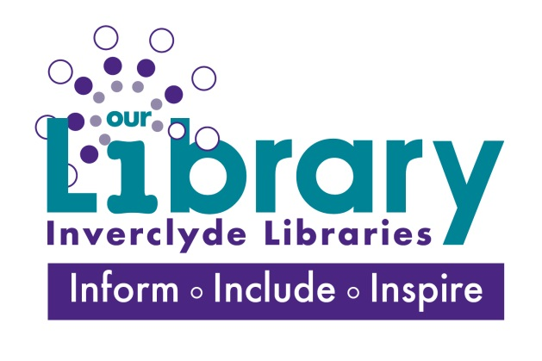
Inverclyde Libraries ‘Making Waves’ Project 2019
<Workshop Name> Sign-Up (10 places)

 | Name | Library Membership No | Email address | Telephone Number | Referred to Privacy Notice
1.
2.
3.
4.
5.
6.

7.
8.
9.
10.
 | Waiting List
 | Name | Library Membership No | Email address | Telephone Number | Referred to Privacy Notice
11.
12.
13.
14.
15.
16.
17.

18.

19.

20.

