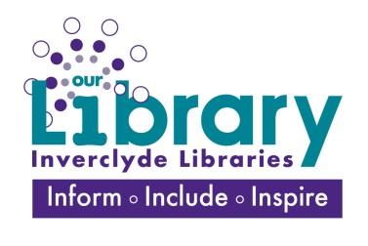
Making Waves Consultation August – October 2019
Ready access to information through digital media has challenged the perceived societal roles of public libraries. Since the mid 1990’s, libraries have reoriented themselves towards public participation beyond lending and reading. Libraries now offer an increasing range of community-focused creative activities. Using information from the State of Queensland research on The Impact of libraries as creative spaces we want to use and build on their creative Spaces Impact Framework to evaluate our libraries as -creative spaces through the creative activities they enable. These activities may be formally organised by our libraries, informally enacted by library clients, or involve a combination of both approaches.
The first thing our consultation set out to do was to identify and generate creative activity – Library staff used the framework to think about and identify creative activity, consider the outcomes and re-imagine existing activities. Using this brainstorming exercise we came up with our survey questions. By connecting with broader data about the needs of our communities, our public libraries can link these with creative activities (existing or new), and align support and service provision accordingly.
We ensure we targeted and included library users, non-users, those who attend groups already established and those working in the culture and creative sector locally – creative individuals with barriers to accessing services, socially isolated people, people with autism, teenagers, new scots and others within the Inverclyde community:
- Reach for Autism,
- Chatty crafters
- New Scots
- Stella Maris Unit (Notre Dame High School)
- Focus group - School pupils from secondary schools across Inverclyde
- Families
- External providers

Methods: Our consultation period ran from Doors Open day (August 31st until October 31st 2019)
“Making Waves” - We are conducting research on developing libraries as Cultural Hubs, offering free creative activities and opening up conversations about culture and creativity in Inverclyde. We'd love to hear from you about what type of cultural / creative activity you engage with currently in Inverclyde and what activities you would like delivered in your local library. This will help us make improvements to our existing offer and prioritize new services. The survey should only take 5 minutes, and your responses are completely anonymous. You can only take the survey once, but you can edit your responses until the survey is closed on 31st October 2019 If you have any questions about the survey, please email us: libraries@invercldye.gov.uk We really appreciate your input!
- Hard copy and online questionnaires
- Focus groups
- Individual meetings with stakeholders and partners
.
We assessed the level of provision already available and the consultation focused on:
- What cultural and creative activities are available in the area?
- What services are used and by whom?
- Where would people most want to access cultural and creative services?
- What form of cultural and creative activities would people most like to attend?
Using the responses we gathered from 88 individuals, local mapping exercise and Audience Agency report for our locale we were able to align creative activity with community needs.
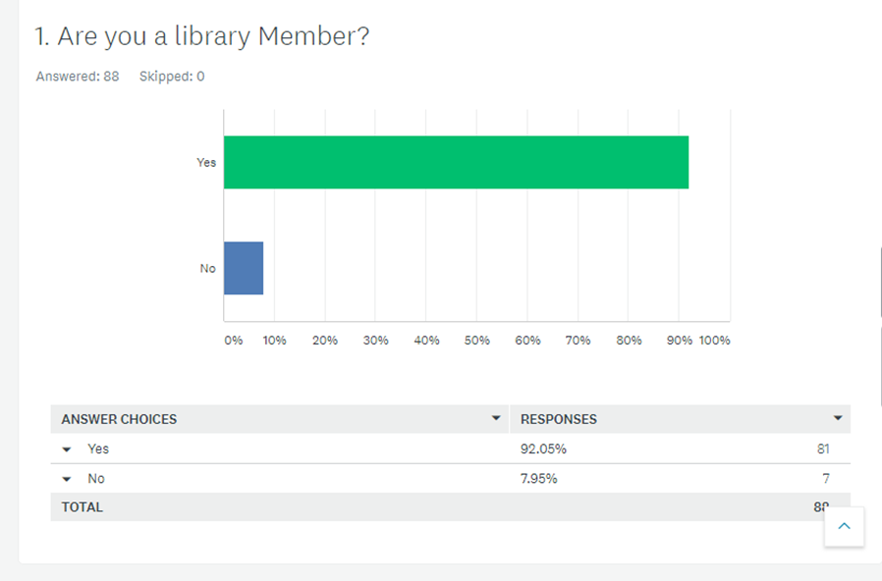
Public libraries are known as trusted and loved places within the community (Varheim et al. 2008). Libraries are public places that can be linked with the capacity and quality of life that an urban or regional centre can offer people who love there (Houghton, 2014). Library places can provide a refuge and a break from the intensity of urban living and work; and a connection for the isolated or lonely.
92% of respondents were library members but some were inactive - through informal questioning many would return to the library for a creative activity.
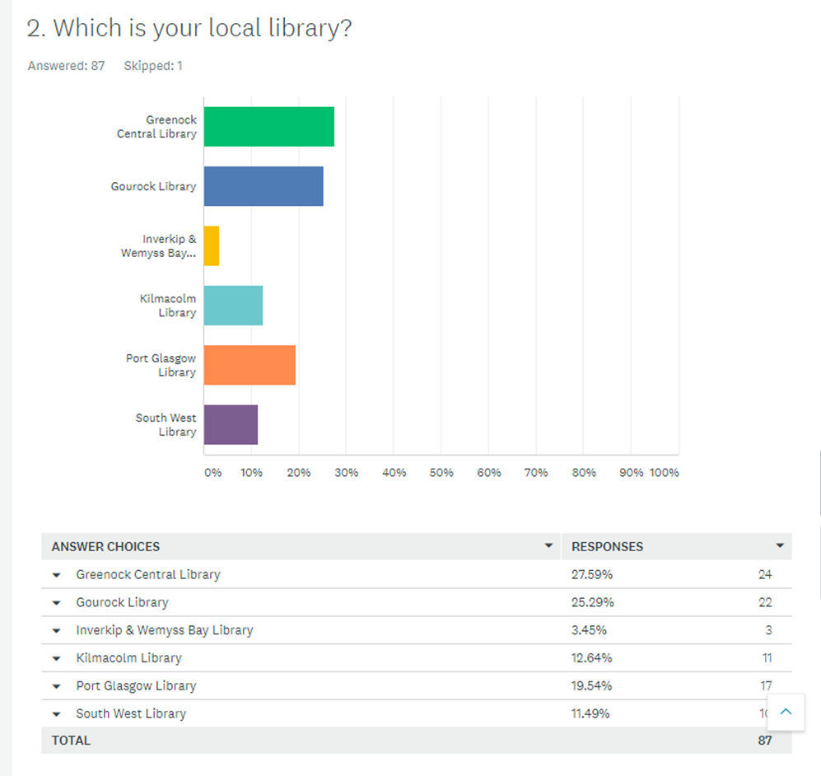

We had a representative sample of respondents from each of our local areas.
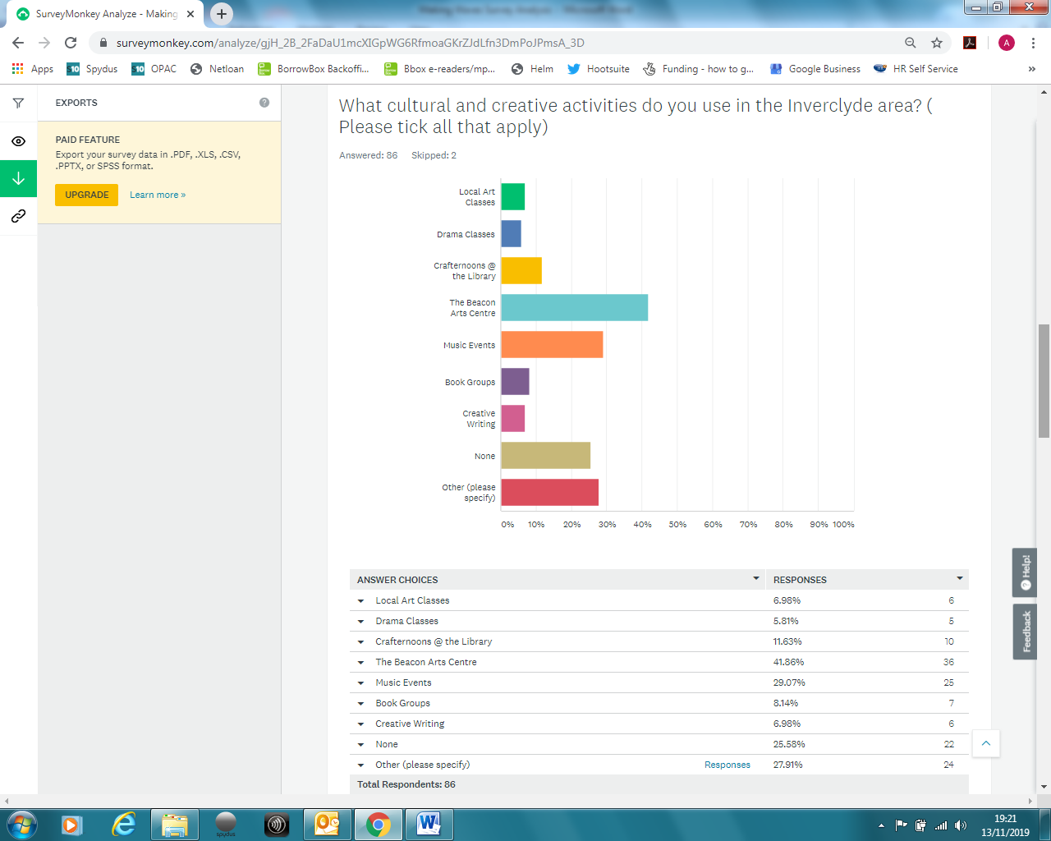

Beacon Arts Centre launched in 2013 out of the long-standing Greenock Arts Guild which was established in 1945. The Beacon is located in Greenock on the banks for the Clyde with spectacular views over the hills of Argyll and Bute and is Inverclyde’s prime provider of arts and creative learning.
The Beacon stages a vast array of performances from award-winning national companies like Scottish Opera and National Theatre of Scotland to large scale community musicals and amateur theatre. There’s also a year round exhibition programme and range of courses and classes for all ages and all abilities including Beacon Youth Theatre and a contemporary dance programme.
So it was good to see our Crafternoons feature highly on responses (along with book groups and creative writing). Music events featured highly 29% and Inverclyde libraries took part in 2017 in the Get it Loud in Libraries initiative in Scotland and hosted a very successful Maisie Peters gig in Central Library and feedback from the night indicated interest in similar events.
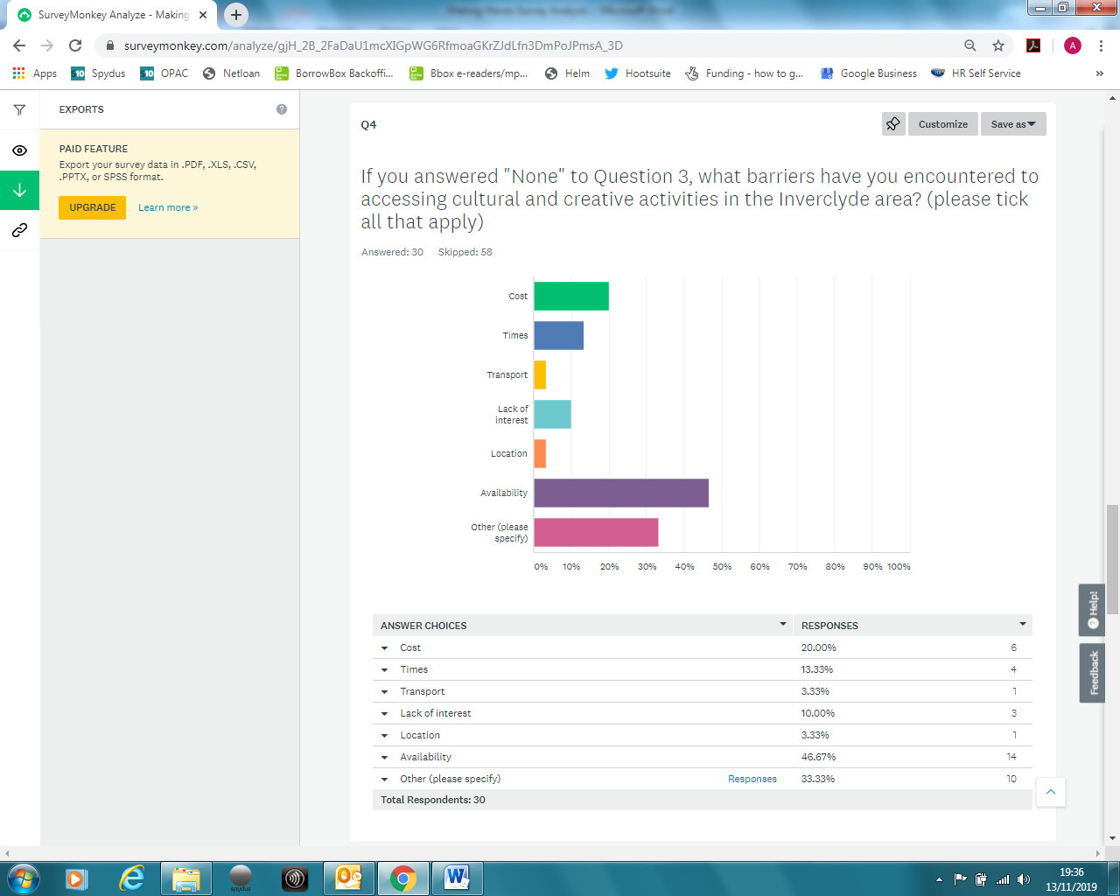

Other responses included “Lack of Awareness”, “Lack of time due to work”, “Areas within library are quite restrictive”, “Unawareness and work commitments” “Don’t know anything about them”, “Work and childcare needs”.
In order for us to be proactive in this area we need to qualitatively asses the social impact on individuals and their communities – our approach must concentrate on the benefits of creative spaces. It is important to remember that a sense of place is developed through the activity that occurs in a space (Tuan 1977) and this is known as Placemaking. It is important to not only identify libraries as creative spaces, but to evaluate them through the diverse range of activities that are enacted in and with them.

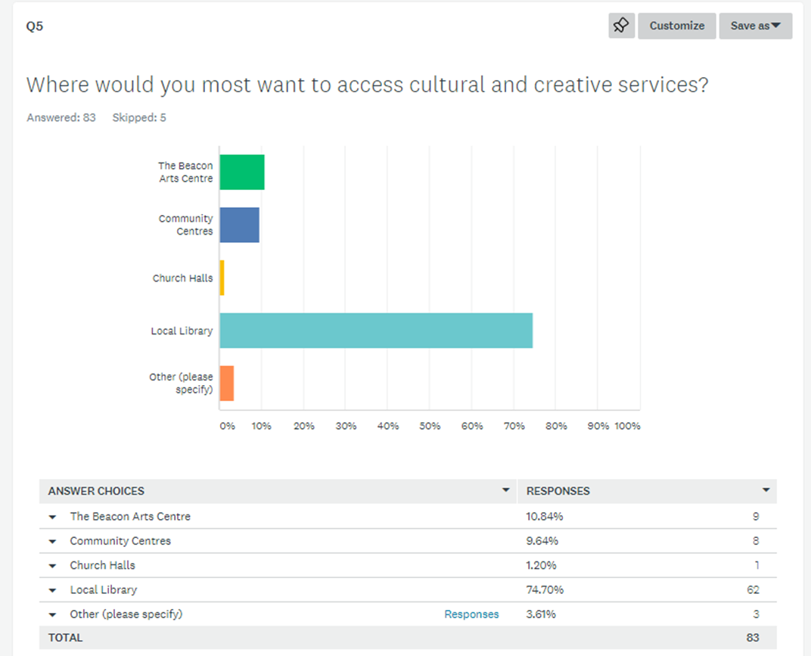

Other responses included “Happy to travel to most venues”, “College”, “Anyone of the above – with the emphasis on local”.
Creativity in libraries can involve building connections with the community, within the community and across different levels of government. Creative practises associated with libraries might support community development - ie facilitating active inclusion for all groups of the community, developing a sense of belonging, connection and involvement with community, social cohesion and collective ownership.

Other responses included – History of Art, Family History, Poetry, Astronomy, Pottery, Film Appreciation, Modern Languages, Topic discussion, Tutorless groups, Photography, Gaelic, Cookery.
Using this consultation we identified and generated creative activity by thinking through what that creative activity might be, reconsidering activities currently offered to communities ( Including those not necessarily thought of as ”Creative”), prompting new activities considering a broader range of creative objectives and outcomes and preparing for and delivering creative activities to deliver maximum impact.
References:
Houghton, K., Foth, M. and Miller, E. (2013). The continuing relevance of the library as a third place for users and non-users of IT: The case of Canada Bay. The Australian Library Journal, 62(1), pp. 27-39.
Tuan, Y. F. (1977). Space and place: The perspective of experience. Minneapolis, University of Minnesota Press.
Vårheim, A. (2009). Public libraries: places creating social capital? Library Hi Tech, 27(3), pp. 372-381.

